SPRINT 4

Team ID : PNT2022TMID37462

CODE:

#include <WiFi.h>//library for wifi

#include <PubSubClient.h>//library for MQtt

#include <ESP32Servo.h>

#define SERVO_PIN 26

#define BUZZER_PIN 2

//DHT dht (DHTPIN, DHTTYPE);// creating the instance by passing pin and typr of dht connected Servo servoMotor;

void callback(char* subscribetopic, byte* payload, unsigned int payloadLength);

//-------credentials of IBM Accounts------

#define ORG "6hr21b"//IBM ORGANITION ID

#define DEVICE_TYPE "sprint004"//Device type mentioned in ibm watson IOT Platform

#define DEVICE_ID "mainproject"//Device ID mentioned in ibm watson IOT Platform

#define TOKEN "1234567890" //Token

String data3;

//float h, t;\ float flamelevel = 0;

const int firingLow = 70; // lowest reading for actively firing

const int firingHigh = 90; // reading for full firing

String data;

//-------- Customise the above values --------

char server[] = ORG ".messaging.internetofthings.ibmcloud.com";// Server Name char publishTopic[] = "iot-2/evt/Data/fmt/json";// topic name and type of event perform and format in which data to be send

char subscribetopic[] = "iot-2/cmd/command/fmt/String";// cmd REPRESENT command type AND COMMAND IS TEST OF FORMAT STRING

char authMethod[] = "use-token-auth";// authentication method char token[] = TOKEN;

char clientId[] = "d:" ORG ":" DEVICE_TYPE ":" DEVICE_ID;//client id

//-----------------------------------------

WiFiClient wifiClient; // creating the instance for wificlient

PubSubClient client(server, 1883, callback ,wifiClient); //calling the predefined client id by passing parameter like server id,portand wificredential void setup()// configureing the ESP32

{

**Serial**.begin(115200); pinMode(BUZZER_PIN, OUTPUT); servoMotor.attach(SERVO_PIN);

delay(10); **Serial**.println(); wificonnect(); mqttconnect();

}

void loop()// Recursive Function

{

float analogValue = analogRead(36);

float flamelevel;

**Serial**.print("Sensor RAW: "); **Serial**.println(analogValue, 0);

flamelevel = map(analogValue, 0, 1024, 100, 0);

**Serial**.print(flamelevel, 0); **Serial**.println("%");

if (flamelevel >= firingHigh) { // stoker is fully firing

tone(BUZZER_PIN,2000); servoMotor.write(180); delay(300); data="alert";

}

if (flamelevel < firingLow) { // fire out data="chill"; noTone(BUZZER_PIN); servoMotor.write(0);

// send alert

}

PublishData(flamelevel); delay(1000);

if (!client.loop()) {

mqttconnect();

}

}

/*.....................................retrieving to Cloud...............................*/

void PublishData(float flamelevel) {

mqttconnect();//function call for connecting to ibm

/*

creating the String in in form JSon to update the data to ibm cloud */

String payload = "{\"flamelevel\":";

payload += flamelevel; payload += "," "\"msg\":\""; payload += data; payload += "\"}";

**Serial**.print("Sending payload: ");

**Serial**.println(payload);

if (client.publish(publishTopic, (char*) payload.c_str())) {

**Serial**.println("Publish ok");// if it sucessfully upload data on the cloud then it will print publish ok in Serial monitor or else it will print publish failed

} else {

**Serial**.println("Publish failed");

} }

void mqttconnect() { if (!client.connected()) {

**Serial**.print("Reconnecting client to ");

**Serial**.println(server);

while (!!!client.connect(clientId, authMethod, token)) {

**Serial**.print(".");

delay(500); }

initManagedDevice();

**Serial**.println();

}

}

void wificonnect() //function defination for wificonnect

{

**Serial**.println();

**Serial**.print("Connecting to ");

WiFi.begin("Wokwi-GUEST", "", 6);

//passing the wifi credentials to establish the connection

while (WiFi.status() != WL_CONNECTED) {

delay(500);

**Serial**.print(".");

}

**Serial**.println("");

**Serial**.println("WiFi connected");

**Serial**.println("IP address: ");

**Serial**.println(WiFi.localIP());

}

void initManagedDevice() { if (client.subscribe(subscribetopic)) { **Serial**.println((subscribetopic));

**Serial**.println("subscribe to cmd OK");

} else {

**Serial**.println("subscribe to cmd FAILED");

}

}

void callback(char* subscribetopic, byte* payload, unsigned int payloadLength)

{

**Serial**.print("callback invoked for topic: "); **Serial**.println(subscribetopic); for (int i = 0; i < payloadLength; i++) { //Serial.print((char)payload[i]); data3 += (char)payload[i];

}

/*Serial.println("data: "+ data3);

if(data3=="lighton")

{

Serial.println(data3); digitalWrite(LED,HIGH);

}

else

{

Serial.println(data3);

digitalWrite(LED,LOW);

}

data3=""; */}

Diagram.json

{

"version": 1,

"author": "Divya selvakumar",

"editor": "wokwi",

"parts": [

{ "type": "wokwi-esp32-devkit-v1", "id": "esp", "top": -123.2, "left": -328.77, "attrs": {} },

{

"type": "wokwi-photoresistor-sensor",

"id": "ldr1",

"top": 137.8,

"left": -96.65,

"attrs": {}

},

{

"type": "wokwi-buzzer",

"id": "bz1",

"top": -100.24, "left": -118.05,

"attrs": { "volume": "0.1" }

},

{ "type": "wokwi-servo", "id": "servo1", "top": -236.33, "left": -115.45, "attrs": {} }

],

"connections": [

[ "esp:TX0", "$serialMonitor:RX", "", [] ],

[ "esp:RX0", "$serialMonitor:TX", "", [] ], [ "ldr1:VCC", "esp:3V3", "red", [ "h0" ] ],

[ "ldr1:AO", "esp:VP", "green", [ "h0" ] ],

[ "esp:GND.1", "ldr1:GND", "black", [ "h0" ] ],

[ "bz1:2", "esp:3V3", "green", [ "v0" ] ],

[ "bz1:1", "esp:D2", "green", [ "v0" ] ],

[ "servo1:GND", "esp:GND.1", "black", [ "h0" ] ],

[ "servo1:V+", "esp:3V3", "green", [ "h0" ] ],

[ "servo1:PWM", "esp:D26", "green", [ "h0" ] ]

]

}

Program&Output: Simulation:

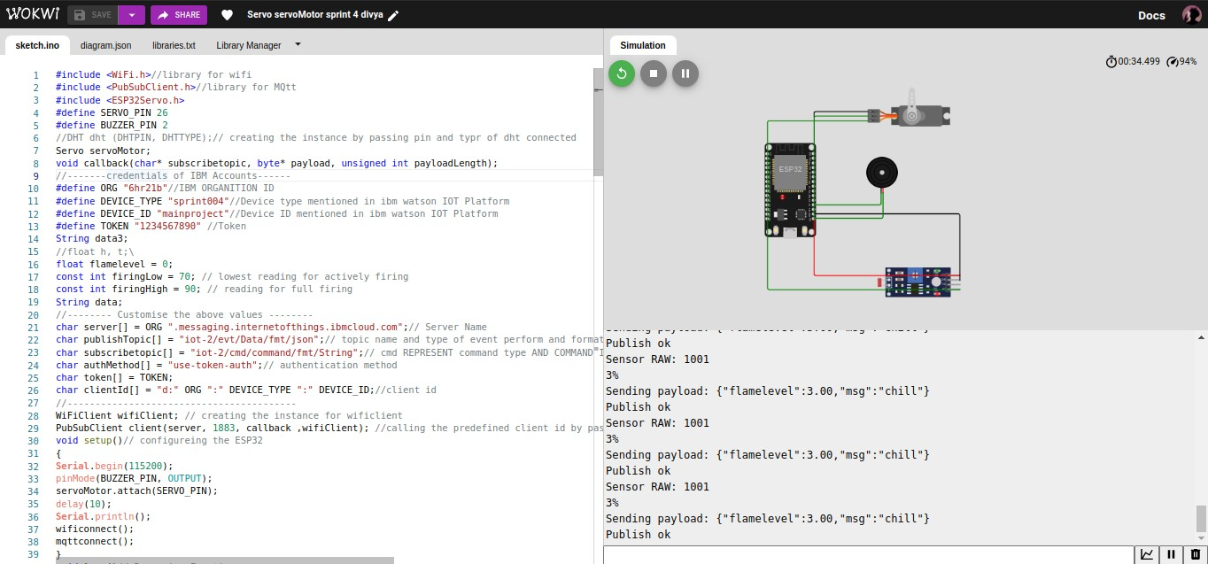

Ibm watson iot platform connection:

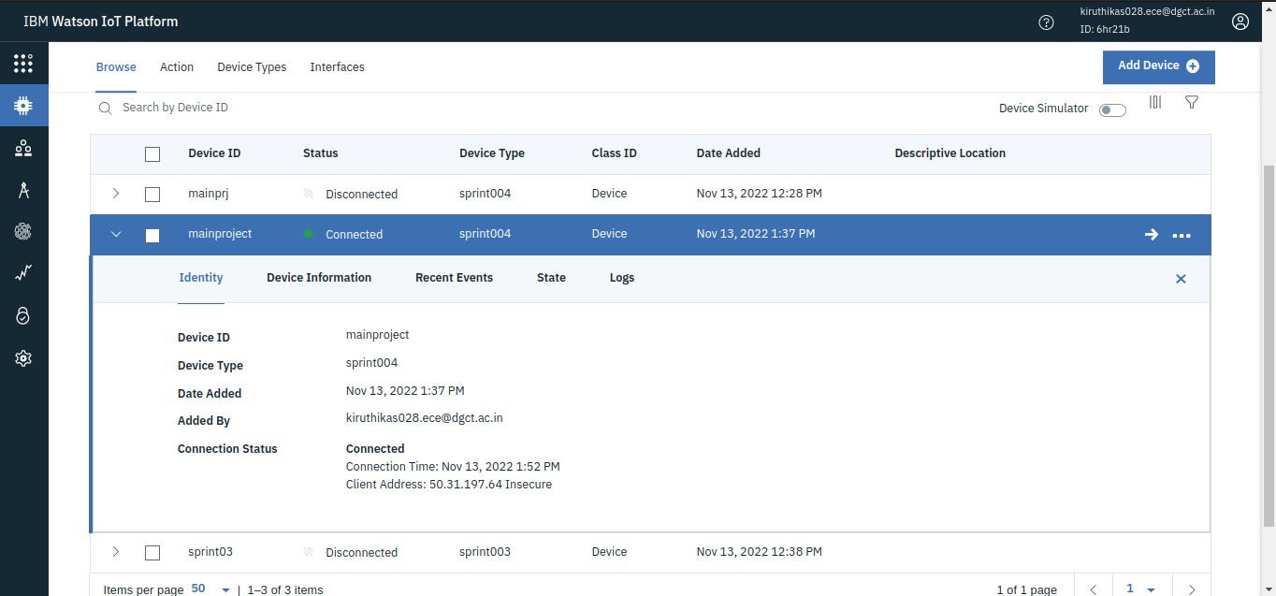

Watson output event:

